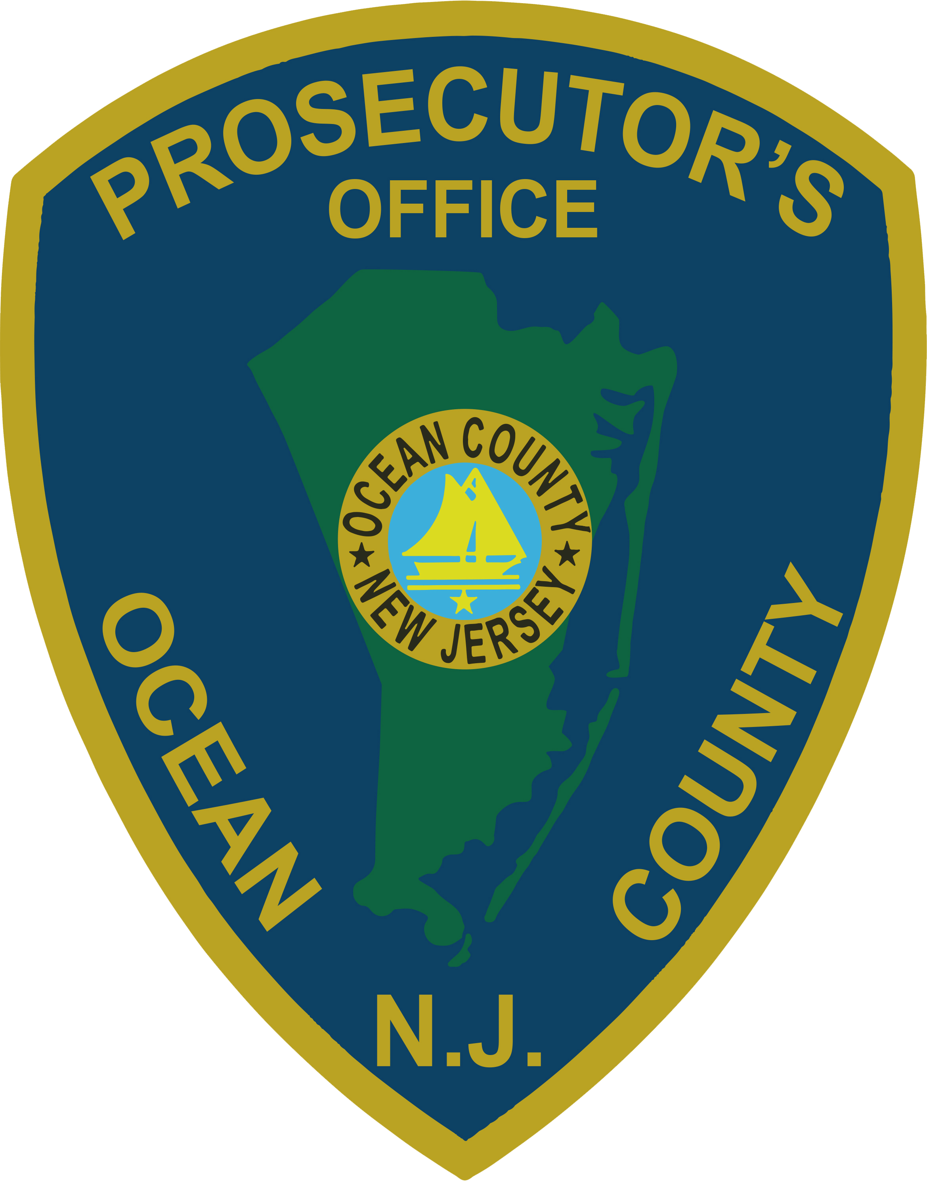 | PRESS RELEASE
FOR IMMEDIATE RELEASE  July 2, 2019 |  | CONTACT: Bryan Huntenburg  Ocean County Prosecutor’s Office  P.O. Box 2191  Toms River, NJ 08753  Office: (732) 929-2027  Mobile: (732) 288-6734  Email: ocpopress@co.ocean.nj.us

LAKEHURST MAN SENTENCED FOR FIRST DEGREE
AND SECOND DEGREE ARMED ROBBERY

Ocean County Prosecutor Bradley D. Billhimer announced today that on Friday, June 28, 2019, Christopher Dupont, age 24, of Lakehurst was sentenced to ten years in New Jersey State Prison by the Honorable Michael T. Collins, J.S.C., as a result of a conviction for First-Degree Armed Robbery. Dupont will be required to serve eighty-five percent of the sentence prior to being eligible for parole, pursuant to the No Early Release Act. The conviction was a result of an incident that occurred on October 31, 2014, in South Toms River. Dupont and an accomplice asked the victim to drive them from Berkeley Township to South Toms River. While she was driving them, they assaulted the victim and stole cash that was in her possession.

Judge Collins also sentenced Dupont to a term of seven years in New Jersey State Prison as a result of a separate conviction for Second-Degree Robbery. This conviction was a result of an incident that occurred on January 20, 2018, in Lakehurst. On this date Dupont made arrangements with the victim to meet in Lakehurst for the purpose of selling him a cellular telephone. When the victim arrived, Dupont threatened the victim and demanded the cash. This sentence is also subject to the No Early Release Act. Judge Collins ran both sentences concurrently.

Prosecutor Billhimer would like to thank the Ocean County Prosecutor’s Office Major Crime Unit, Ocean County Prosecutor’s Office High Tech Crime Unit, South Toms River Police Department, Lakehurst Township Police Department and the Ocean County Sheriff’s Department Crime Scene Investigation Unit in bringing Dupont to justice.

Follow the Office of the Ocean County Prosecutor online on Facebook, Twitter and Instagram.
The social media links provided are for reference only.
OCPO does not endorse any non-governmental websites, companies or applications.
For additional information, visit our Facebook Page at https://www.facebook.com/OCPONJ/

