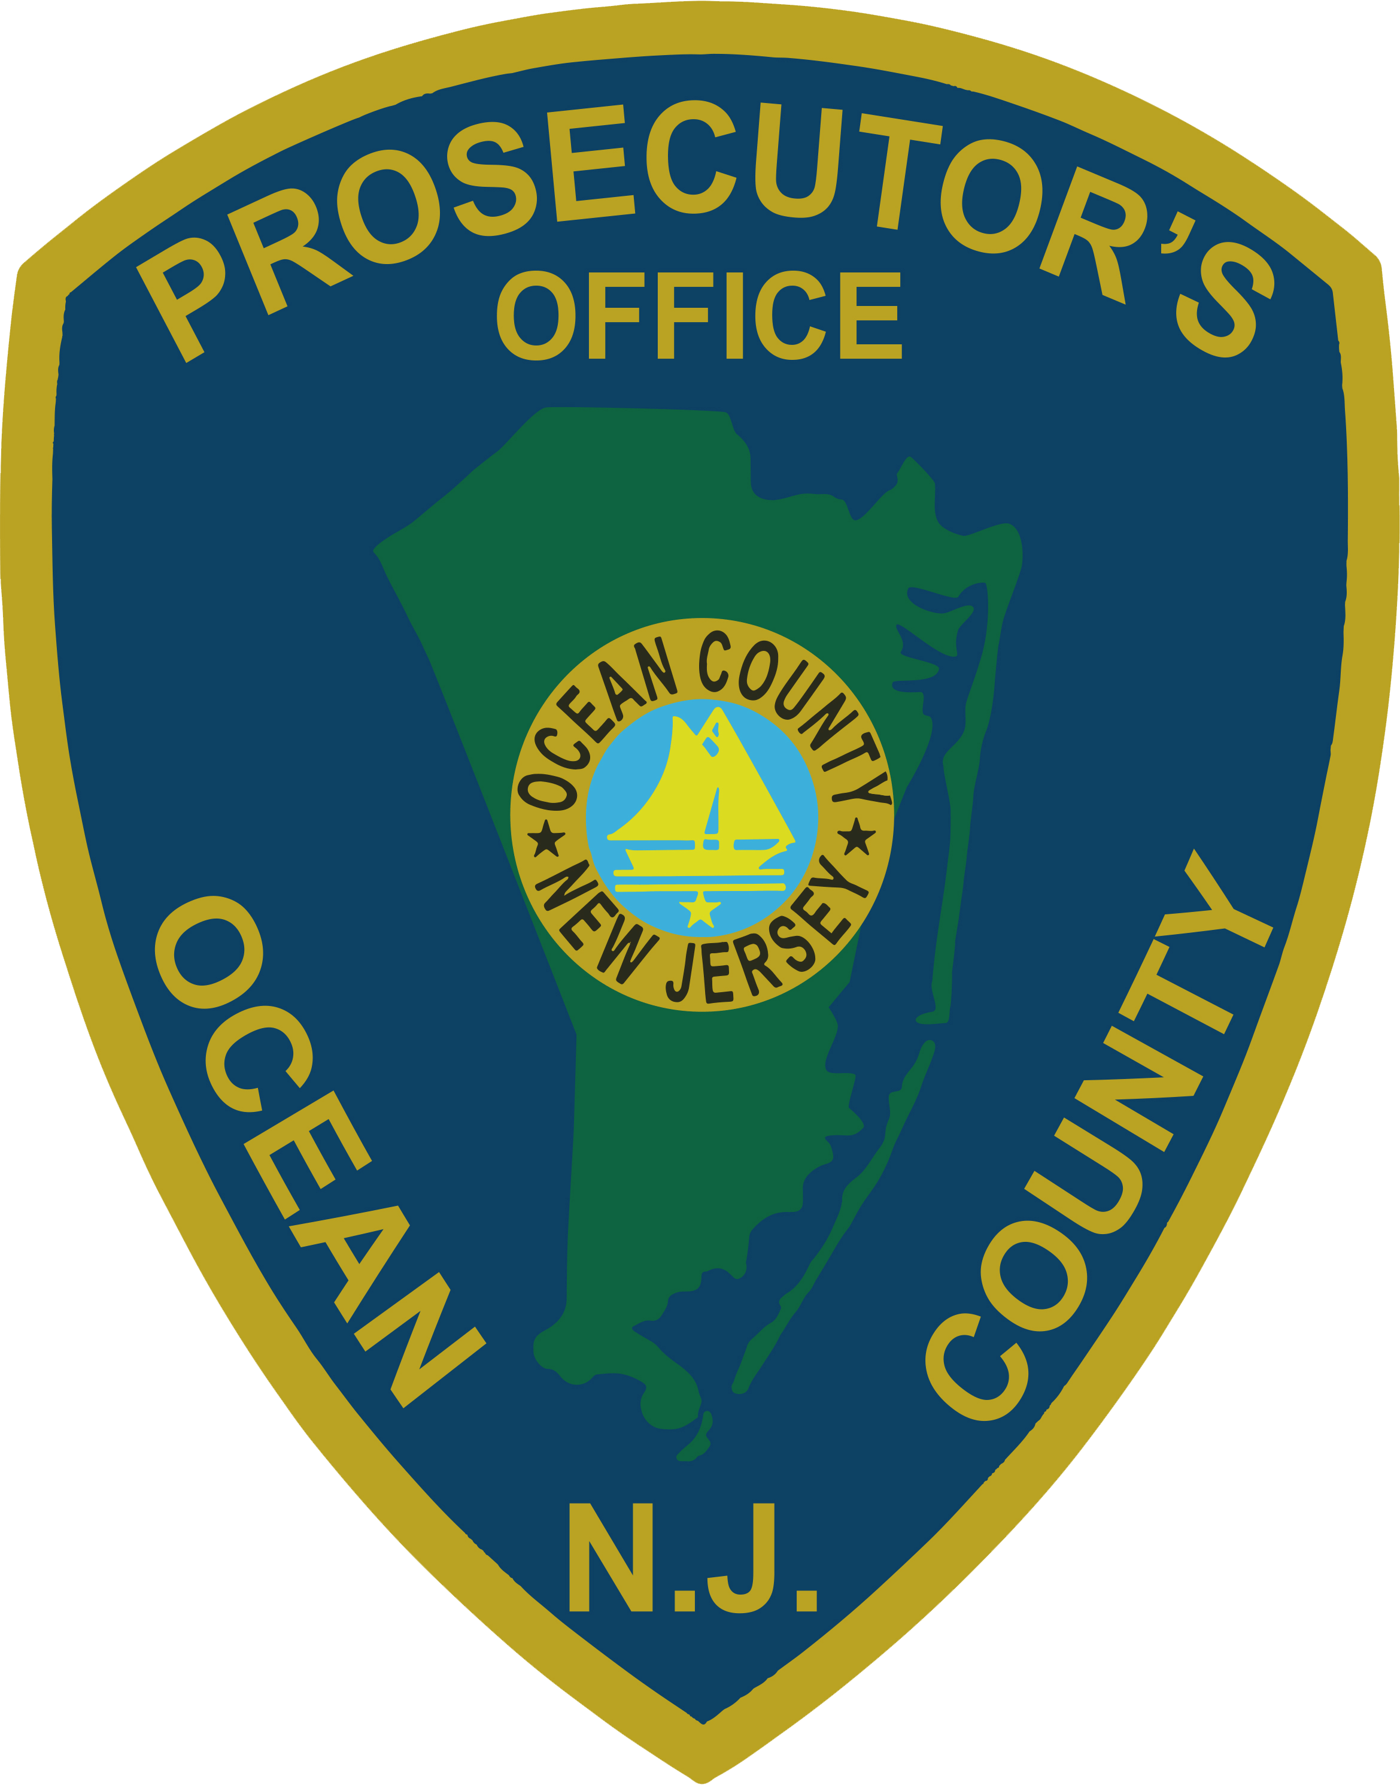 | PRESS RELEASE
FOR IMMEDIATE RELEASE  August 8, 2019 |  | CONTACT: Bryan Huntenburg  Ocean County Prosecutor’s Office  P.O. Box 2191  Toms River, NJ 08753  Office: (732) 929-2027 Mobile: (732) 288-6734  Email: ocpopress@co.ocean.nj.us

TOMS RIVER HOMICIDE

Ocean County Prosecutor Bradley D. Billhimer and Toms River Police Chief Mitch Little announced that on Wednesday, August 7, 2019, at approximately 8:42 p.m. Toms River Township Police were dispatched to 150 Route 37 West, Deer Chase Professional Park, for reports of an assault. Police arrived to find an unresponsive female. After lifesaving efforts by first responders, the victim was pronounced dead at Community Medical Center and the investigation became a homicide. This joint investigation between the Ocean County Prosecutor’s Office Major Crime Unit, Toms River Township Police Department and Ocean County Sheriff’s Department Crime Scene Investigation Unit is ongoing and no further information will be released at this time. There is no danger to the public at this time

Follow the Office of the Ocean County Prosecutor online on Facebook, Twitter and Instagram.
The social media links provided are for reference only.
OCPO does not endorse any non-governmental websites, companies or applications.
For additional information, visit our Facebook Page at https://www.facebook.com/OCPONJ/

