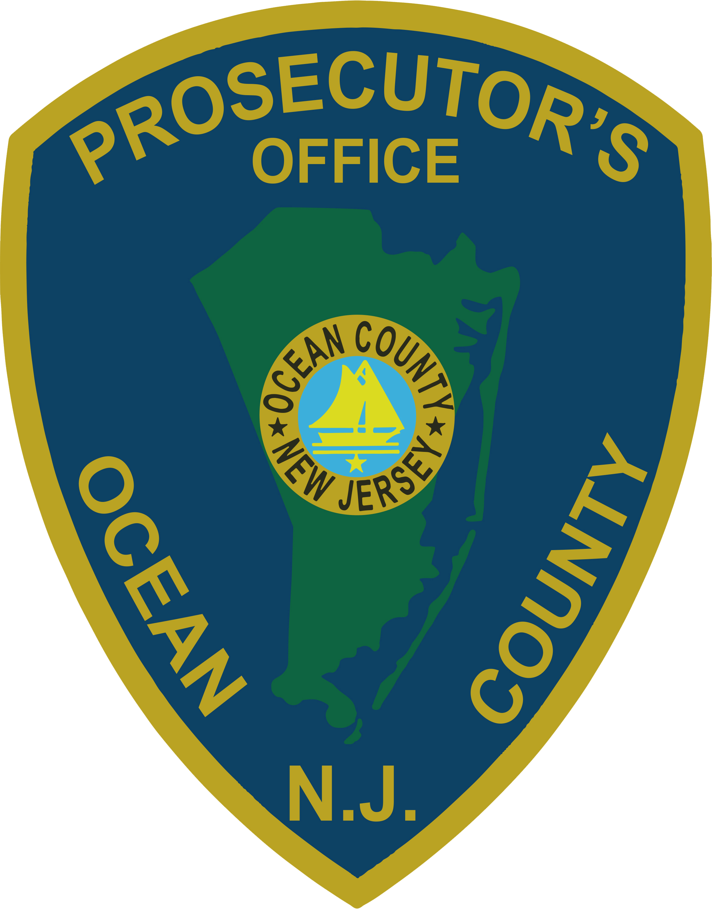 | PRESS RELEASE
FOR IMMEDIATE RELEASE  June 17, 2019 |  | CONTACT: Bryan Huntenburg  Ocean County Prosecutor’s Office  P.O. Box 2191  Toms River, NJ 08753  Office: (732) 929-2027  Mobile: (732) 288-6734  Email: ocpopress@co.ocean.nj.us

LAKEWOOD WOMAN CHARGED WITH SECOND DEGREE ENDANGERING THE WELFARE OF A CHILD

Ocean County Prosecutor Bradley D. Billhimer announced that Chaya Shurkin, 25, of Lakewood, has been charged with Endangering the Welfare of a Child in violation of N.J.S.A. 2C:24-4a(2) -- a crime of the Second Degree.
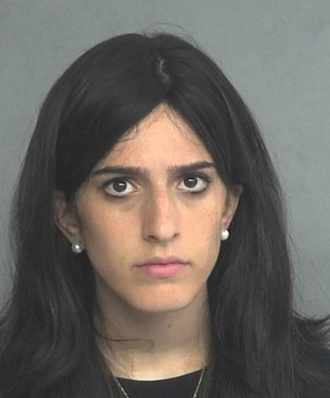
On May 6, 2019, Officers from the Lakewood Township Police Department responded to a Lakewood residence for a report of a child in distress. The Officers found a neighbor attempting to perform CPR on the child, who was then transported to Monmouth Medical Center Southern Campus. The child later expired at the hospital.

Prosecutor Billhimer stated “A thorough and extensive investigation revealed that the child had been left alone in Shurkin’s motor vehicle for approximately two-and-one-half hours with the car turned off, in the heat. Shurkin was the child’s mother. The investigation determined that the act of leaving the child in the car unattended for such a long period of time was the cause and manner of the child’s death.”

Prosecutor Billhimer would like to thank the Ocean County Prosecutor’s Office Major Crime Unit, the Ocean County Sheriff’s Department Crime Scene Investigation Unit, the Lakewood Township Police Department, and the State and Ocean County Medical Examiner’s Offices for their assistance with this very comprehensive investigation.

The public and media are reminded that all defendants are innocent until proven guilty beyond a reasonable doubt in a court of law.

Follow the Office of the Ocean County Prosecutor online on Facebook, Twitter, and Instagram.
The social media links provided are for reference only.
OCPO does not endorse any non-governmental websites, companies or applications.
For additional information, visit our Facebook Page at https://www.facebook.com/OCPONJ/

