 | PRESS RELEASE
FOR IMMEDIATE RELEASE  July 1, 2019 |  | CONTACT: Bryan Huntenburg  Ocean County Prosecutor’s Office  P.O. Box 2191  Toms River, NJ 08753  Office: (732) 929-2027  Mobile: (732) 288-6734  Email: ocpopress@co.ocean.nj.us

BRICK TOWNSHIP MASSAGE THERAPIST CHARGED WITH
SEXUAL ASSAULT

Ocean County Prosecutor Bradley D. Billhimer announced today that Jonathan Higgins, age 28, of Toms River, was charged with Sexual Assault in violation of N.J.S.A. 2C:14-2c(1) on June 27, 2019.
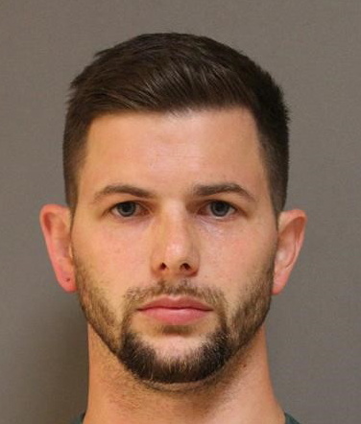
Higgins, while employed as a massage therapist at Hand and Stone Massage & Facial Spa in Brick Township, committed an act of penetration on a female customer during the course of a massage on June 25, 2019. Higgins was arrested and processed at Brick Township Police Headquarters and transported to the Ocean County Jail where he is lodged pending a detention hearing.

Prosecutor Billhimer is urging anyone having information or who feels they may be a victim to please contact Detective Nicole Testa of the Ocean County Prosecutor’s Office at 732-929-2027 or Detective Timothy McCarthy of the Brick Township Police at 732-262-1100.

The public and media are reminded that all defendants are innocent until proven guilty in a court of law.

Follow the Office of the Ocean County Prosecutor online on Facebook, Twitter and Instagram.
The social media links provided are for reference only.
OCPO does not endorse any non-governmental websites, companies or applications.
For additional information, visit our Facebook Page at https://www.facebook.com/OCPONJ/

