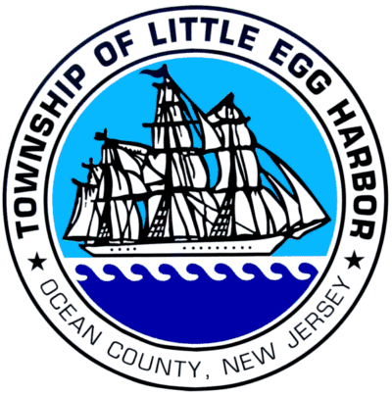  (609) 296-7241 ext. 230  Fax (609) 296-5352  www.leht.com | LITTLE EGG HARBOR TOWNSHIP  665 Radio Road, Little Egg Harbor, NJ 08087

VIA Email: opra+request-4990-a7d0d1ab@requests.opramachine

July 2, 2019

Jessica Martin

RE: OPRA Request 102 West Holly
2019-111

To Whom It May Concern:

As a follow-up to our response to a records request submitted for the above-referenced location the storage facility where the records are located is still closed. At this point in time we are not sure when the facility will be reopened. If you are no longer in need of the documents requested please email bflynn@leht.com your desire for no longer needing the records and your request will be deemed complete. If you still need the records be certain your original OPRA will be retained by the Clerk’s office and we will fulfill your request as soon as access is granted into the storage facility.

If you have any questions, please do not hesitate to contact our office.

Sincerely,

Diana K. McCracken, RMC

Diana K. McCracken, RMC
Township Clerk

